MODULE-2
Energy Conversion and Storage
Batteries
Introduction to batteries:
Battery: A battery is an assembly of two or more cells, (primary or secondary) connected in series or parallel or both that can store chemical energy in the form of active materials and supply necessary electrical energy through electrochemical redox reaction when it is required.

Principle components of a battery are:
- An anode where oxidation occurs.
- A cathode where reduction occurs.
- An electrolyte, which is ionically conducting.
- A separator to separate anode and cathode compartments.

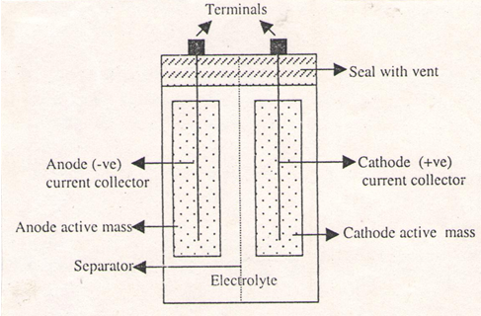

Classification of batteries

1.Primary batteries: In these batteries the cell reaction is not reversible, after discharging cannot be rechargeable.
Ex. Zn-MnO₂.battery, Li-MnO₂ battery
2. Secondary batteries: In these battery the cell reaction is completely reversible, after discharging can easily rechargeable.
Ex. Lead-acid battery, Ni-MH battery. Ni-Cd battery, Li-Ion battery.
3.Reserve batteries: In these batteries, one of the active components (e.g. electrolyte) of the battery is separated from the rest of the components. It is assembled just before the use.
Ex. Mg-water activated battery. Zn-Ag₂O battery, Mg-AgCl battery

Construction, Working and Applications of modern batteries

Sodium- ion battery (Na-ion battery)

The chemistry and electrochemistry of electrode materials for Na-ion batteries are sufficiently different from that of their Li-ion counterparts that candidates suitable for practical batteries have become available only recently.

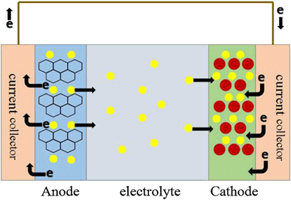

A conventional Sodium ion battery consists of and a metal oxide such as Sodium cobalt oxide (NaCoO₂) forms the cathode and carbon (graphite) as anode. The electrolyte consists of a Sodium salt in an organic solvent. The salts include Sodium hexa fluoro phosphate NaPF₆, Sodium tetra fluoro borate NaBF₄ and Sodium perchlorate NaClO₄. The solvents used are ethylene carbonate, dimethyl carbonate, and diethyl carbonate.

- The Cell reactions are
At Anode:
Na_{x}C₆ xNa⁺ + xe⁻ + 6C

At Cathode:
Na_{1-x} CoO2 + xNa⁺+ xe⁻ NaCoO₂

The overall reaction of lithium ion battery is
Na_{1-x} CoO₂ + Na_{x}C₆ NaCoO₂ + 6C
Applications:
- It is used in Electrical Vehicle (low cost of sodium, compared to that of lithium)
- Mainly Used for large-scale electric storage applications
Solid State battery (Li-polymer battery)
Lithium batteries
These batteries with high energy density, high energy efficiency, high voltage and long life cycle.
Lithium has the following characteristics.
- It is light weight.
- It has high electrochemical equivalence (3.86 Ah g⁻¹).
- It has good electrical conductivity.
- It has high standard electrode potential (-3.05V).

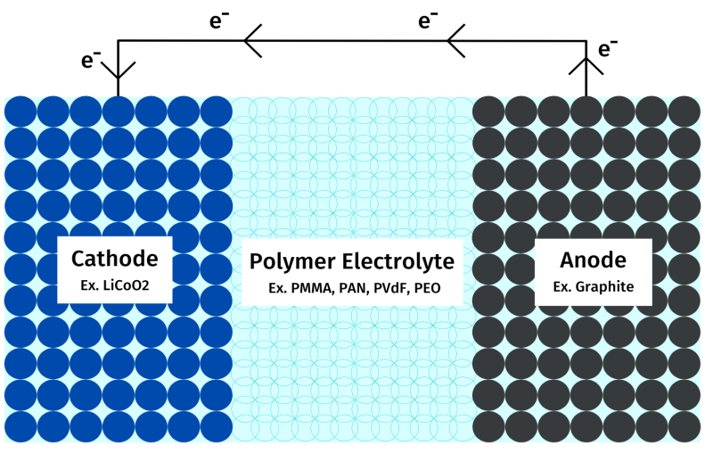
Construction :
A conventional lithium polymer battery consists of and a metal oxide such as lithium cobalt oxide (LiCoO₂) forms the cathode and carbon (graphite) as anode. The electrolyte consists of a polymer made of PMMA, (Poly(methyl methacrylate) PAN (Polyacrylonitrile) etc The cell delivers an emf of 4V.
Working:
These batteries operate on the principle of de-intercalation and intercalation of lithium ions from positive electrode materials to negative electrode materials.

Electrode reaction:
Anode reaction: Li_{x}C_{n} → C_{n} + xLi ⁺ + xe⁻

Cathode reaction: Li_{1-x}CoO₂+ xLi ⁺ + xe⁻ → LiCoO₂

Over all reaction: Li_{1-x}CoO₂+ Li_{x}C_{n} → LiCoO₂+ C_{n}
Applications:
- It is used in Electrical Vehicle
- Used in medical devices such as pacemakers etc
- Used as gardening tools and equipment such as a lawnmower etc
Flow battery (Vanadium redox flow battery) -VRFB
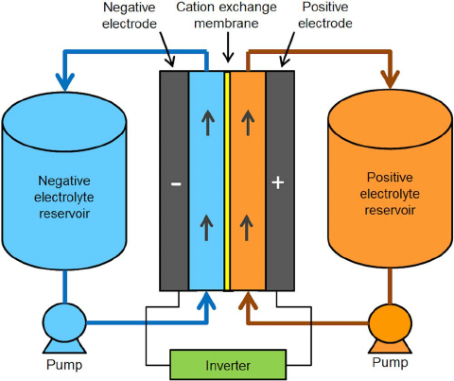

Construction:
Anode: V²⁺/V³⁺ redox couple in H₂SO₄ electrolyte circulated over Carbon base electrode.
Cathode: V⁴⁺/V⁵⁺ redox couple in the form of Oxygenated species, VO²⁺/VO₂⁺ in H₂SO₄ electrolyte circulated over Carbon base electrode
Separator: Perflurosulphuric acid (Nafion) polymer in ion exchange membrane
Working: During Discharging

Anode: V²⁺ V³⁺ + e⁻
Cathode: VO₂⁺ + 2H⁺ + e⁻ VO²⁺ + H₂O
During Recharging

Cathode: V³⁺ + e⁻ V²⁺
Anode: VO²⁺ + H₂O VO₂⁺ + 2H⁺ + e
Applications:
- It is used in UPS
- It is used in Power Conversion (DC- AC and AC- DC)
- It is used in Commercial & Industrial, Electric Vehicle charging
- Used in Storing energy from renewable sources such as Wind and Solar

Fuel Cells
Definition:
Fuel cell is defined as a galvanic cell in which the electrical energy is directly derived by the combustion of chemical fuels supplied continuously.
Fuel cell is represented as
Anode/Electrolyte/Cathode

At anode, fuel undergoes oxidation, Fuel oxidized product + ne
At cathode, oxidant is reduced, oxidant + ne reduced product

Construction, Working and Applications of Methanol–Oxygen fuel cell (CH₃OH- O₂)
Methanol is an efficient electroactive organic fuel at low temperature.
Anode: CH₃OH
Cathode: Oxygen
Electrolyte: H₂SO₄
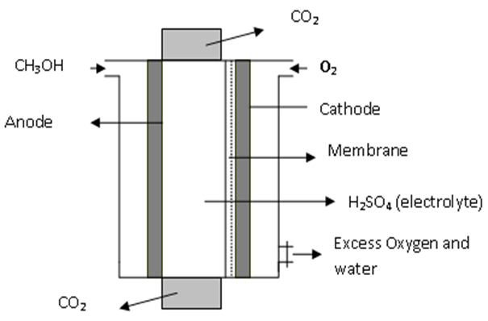

Construction: It consists of anode and cathode made of platinum. Sulphuric acid acts as the electrolyte. A membrane is inserted adjacent to the cathode on the electrolyte side to minimize the diffusion of methanol into the cathode. Methanol – H₂SO₄ mixture is circulated through the anode chamber. Pure oxygen is passed through the cathode chamber.
Working:

Advantages
- Methanol has low carbon content
- The OH group is easily oxidisable
- Methanol is highly soluble in water
Uses
- It is used in military applications and large-scale power productions.
- It is also used in fuel cell vehicles and space shuttles.

Construction, Working and Applications of Polymer Electrolyte Membrane (PEM) Fuel Cell
Construction:
It is relatively new and fast-growing technology.
These cells operate at low temperature.
Solid polymer membranes capable of H+ migration used.
Teflon-based ion-exchanger membranes containing sulphonic acid group (-SO3H) are frequently used.
The cell is compact as the membrane can be very thin. Porous carbon electrodes impregnated with Pt. are used as electrode.
H2 and O2 are normally used as fuel and oxidant, respectively
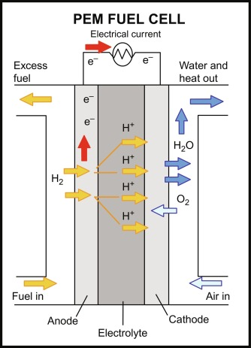

The cell reactions are

At the anode (oxidation): H₂→ 2H⁺ + 2e
At the cathode (reduction): 1/2O₂ + 2H⁺ + 2e- → H₂O
The overall cell reaction: H₂ + 1/2O₂ → H₂O
Applications
- Used as a stationary power generation unit for hospitals, hotels, commercial buildings etc
- They are also used to power fuel cell vehicles, including forklift, automobiles, buses, trains, boats, motorcycles, and submarines.

Solar Energy
Introduction: Solar energy is the energy obtained by capturing heat and light from the Sun. Energy from the Sun is referred to as solar energy. Technology has provided a number of ways to utilize this abundant resource. It is considered a green technology because it does not emit greenhouse gases.
Solar Cell:
The combination of p & n types of semiconductors is called semi conductor diodes. These diodes when exposed to magnetic radiation (sunlight) electricity is generated. Such devices are called as Photovoltaic cell (PV cell) or Solar cell.
Photovoltaic Cells
Photovoltaic cells are semiconductor device which convert solar energy into electrical energy. (Photovoltaic cell is based on the principle of photoelectric effect).
Importance of Solar PV cell
As a renewable source of power, solar energy has an important role in reducing greenhouse gas emissions and mitigating climate change, which is critical to protecting humans, wildlife, and ecosystems. Solar energy can also improve air quality and reduce water use from energy production.
In Homes it can be used for lighting, spinning of fans, grinding grains, transistor radios, small TV sets and Tape recorders etc

Construction & Working of Photo Voltaic (PV) Cell
Construction: A typical silicon photovoltaic cell is composing of a thin wafer consisting of an ultra-thin layer of Phosphorous doped (n-type) silicon on the top and boron doped (p-type) silicon at the bottom. Hence a p-n junction is formed between the two. A metallic grid above the diode forms one of the electrical contacts and allows the light to fall on the semiconductor. The anti-reflexive layer (Silicon nitride or TiO2) present in between the metallic grid increases the transformation of sunlight to a semiconductor. The other metallic layer at the back of the semiconductor forms another electrical contact.
Working: Electromagnetic radiation consists of photon. The photon carries a certain amount of energy. It is given by the Planck Constant equation is E=hc/λ where h is called Planck constant C is the velocity of light and λ is wavelength of the radiation. When the electromagnetic radiation falls on the p-n junction diode, electron pair hole is generated. Electrons move and collect at the n-type end and the holes moves towards the p-type end, on connecting these two ends trough conductor flows between them to an external circuit.

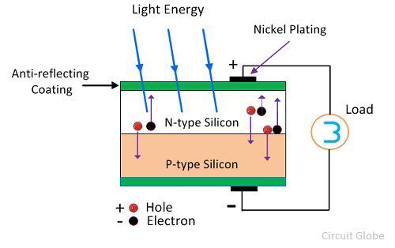

Advantages of P V cells
- No emissions, no combustion or radioactive residues for disposal.
- Low operating cost (no fuel).
- No moving parts and so no wear and tear.
- No recharging.
- The Solar power is pollution free.
Disadvantage of P V cells
- High installation cost.
- Energy can be produced only during the day time.
- The Solar power is not available at night.
Application of Solar Cells / PV Cells
- Solar energy is used to power radio and TV stations.
- Solar energy can be used for power generation in remotely situated places like schools, homes, clinics and buildings.
- Water pumps run on solar energy in remote areas.

MOST REPEATED QUESTIONS IN VTU EXAM

1. Define batteries. Explain the construction, working and applications of Na - ion battery. (7 marks)
2. Explain classification battery (6 Marks)
2) Explain the components in the battery? (6 marks)
3) Describe construction, working and applications of Li-polymer solid state battery. (7marks)
4) Explain construction, working and applications of Vanadium redox flow battery. (7 marks)
5) Define fuel cells. Explain the construction, working and applications of Methanol-oxygen fuel cell?
6) Explain the construction, working and applications of polymer electrolyte membrane (PEM) fuel cell.
7) What are photovoltaic cells? Explain the construction and working of solar photovoltaic cell.
8) Mention advantages and disadvantages of PV Cell. (6 Marks)

*************************************************

